**Problem 1: Jumble Words generator**

Write a program that takes string as input and generates all possible valid words (min 3 characters) as per dictionary provided.

config: [dictionary.txt](https://www.scrapmaker.com/download/data/wordlists/dictionaries/dictionary.txt) containing list of words per line

**Example:**

Input: BLADE

Output:

BAD, LAD, LED, ALE, ...

BALD, LEAD, BLED, …

BLEAD, ABLED, ..

Solution 1:-

#include <bits/stdc++.h>

using namespace std;

void printSubsequence(string input, string output)

{

if (input.empty()) {

if(output.size() >=3)

cout << output << endl;

return;

}

printSubsequence(input.substr(1), output + input[0]);

printSubsequence(input.substr(1), output);

}

// Driver code

int main()

{

string output = "";

string input = "abcd";

printSubsequence(input, output);

return 0;

}

**Problem 2: Count the squares**

Write a program to count the total number of squares in a shape with pattern shown below (size: 4). Input will be number of squares on the bottom line.

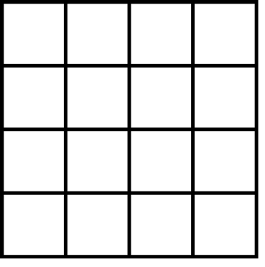

Sample Shape Size: 4

Input: 1; Output: 1

Input: 2; Output: 5

Solution : 2

#include <iostream>

using namespace std;

int countSquares(int n)

{

return n * (n + 1) * (2*n + 1) / 6;

}

int main()

{

int n;

cin>>n;

cout << "Count of squares is " << countSquares(n);

}

**Problem 3: Find the sum**

Write a program to find the sum of all the values of x in a multilevel nested object as shown below:

example = [{x: 1}, {x: 2}, {x: 3}, {x: [{x: 4}, {x: 5}, {x: 6}, {x: [{x: 7}, {x: [{x: 8}]}]}]}, {x: 9}];

Note - the above object is just an example. The object can be nested to any level.

Solution : 3

**sum = 0**

**# iterating key value pair**

**for key ,value in array.items():**

**if value and 'x' in value.keys():**

**# Adding value of sharpness to sum**

**sum += value['x']**

**# printing sum**

**print(sum)**